WORK INTERGRATED LEARNING
XISD6329 - Task 2
Mobile Application and Website

Iziko Art Gallery Museum
Client: Iziko Museums of South Africa
Client Contact: Chief Educator of Art - Rory Emmett

Team
Group name: Core3 Systems
Group Members:
Rafiqah Kirby – ST10438554
Armalene Magerman – ST10454097
Chloe Langenhoven – ST10435895

Due date: 19 October 2026
Table of Contents
Table of Figures 3
Introduction 4
Github links : 4
Project Plan 5
Project Schedules (Gantt Chart) 6
DevOps Lifecycle 7
Site Maps 8
Team Members and Allocation 9
Wireframes 12
Website wireframe 12
App wireframes 13
Guide on how to set up app 16
References 19

Table of Figures

Figure 1: Project Plan -Milestone and Deliverable 5
Figure 2: Project Schedule Table 6
Figure 3: DevOps Lifecycle Diagram 7
Figure 4: Website Site Map 8
Figure 5: Mobile Application Site Map 8
Figure 6: Rafiqah CV 9
Figure 7: Armalene CV 10
Figure 8: Chloe CV 11

Introduction

This project is a continuation of the work completed in XISD5319 for the Iziko Museums of South Africa. In XISD5319, the focus was on research requirements and designing a proposed mobile application to make African art more accessible to people who cannot visit the museum in person.
XISD6329 builds on this previous work by continuing with the planning, development and improvement of the project. The project is being extended to include both a website and a mobile application. The research and prototype designs from XISD5319 will be used as the foundation. The team will update the project plan, create sitemaps and wireframes, develop the prototypes and use the DevOps lifecycle to manage the development process.
The main purpose of the project is to make it easier for people to explore and learn about African artwork using a mobile phone or computer. Users will be able to view artwork and learn about its history, culture and background from anywhere. The project is especially aimed at young people and international tourists, as the application can make learning about African art more interesting and encourage tourists to visit the museum.
The main goals are to:
- Display Iziko artwork on a mobile phone or computer.
- Provide information about the history and culture of each artwork.
- Create a simple and easy-to-use website and mobile application.
- Make African art accessible to people around the world.
- Encourage people to visit the museum in person.
- Use technology to promote and preserve African cultural heritage.
GitHub will be used for version control, with team members regularly committing and pushing their work. Testing will also be completed to find problems and make improvements before the final submission.
The project will be completed at a low cost by using resources already available to us as students. Some risks include technical problems, delays, limited experience and difficulties with testing users from other countries. Local users and tourists can be used for testing to collect feedback and improve the final solution.

Github links :
https://github.com/ST10438554-kirby/IzikoArtGalleryWebsite
https://github.com/ST10438554-kirby/IzikoArtGalleryApp

YOUTUBE LINK:
https://youtu.be/L8o4PA9xj6g?si=dr2tLjZJyE9AvQJs

Project Plan

The updated project plan provides a schedule of the activities required to complete XISD6329 Task 2. The activities are built on the previous XISD5319 project and include the development of the website and mobile application, creation of the sitemap and wireframes, GitHub version control, testing and final documentation. Deliverables have been allocated to the team members according to their roles and responsibilities.
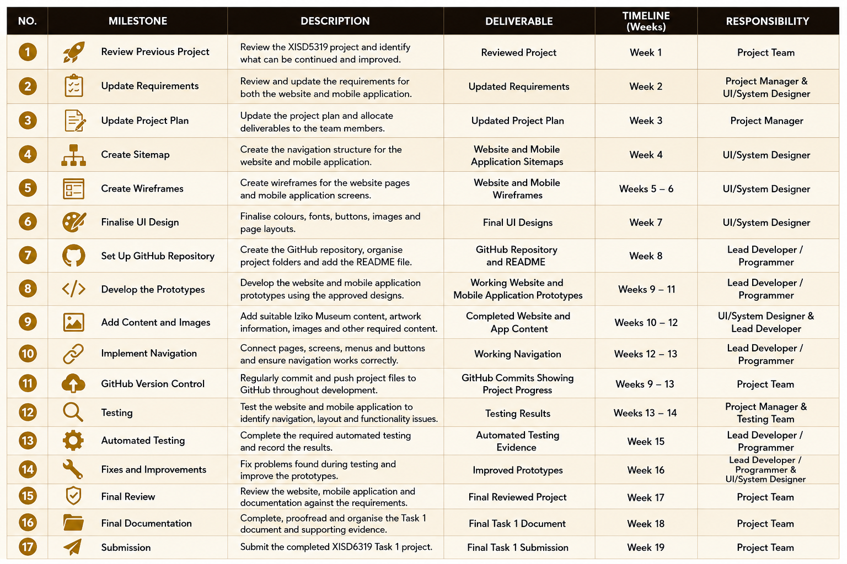
Figure 1: Project Plan -Milestone and Deliverable

Project Schedules (Gantt Chart)

The Gantt chart provides a visual representation of the project schedule. It shows when each activity will start and finish and how the activities overlap during the development period. The Gantt chart shows the planned sequence of activities from reviewing the previous project through to the final submission. The project begins with planning and requirements updates before moving into design activities such as the sitemap and wireframes. Development, content creation and GitHub version control take place during August. Testing and improvements are completed at the end of the development period, followed by final documentation.

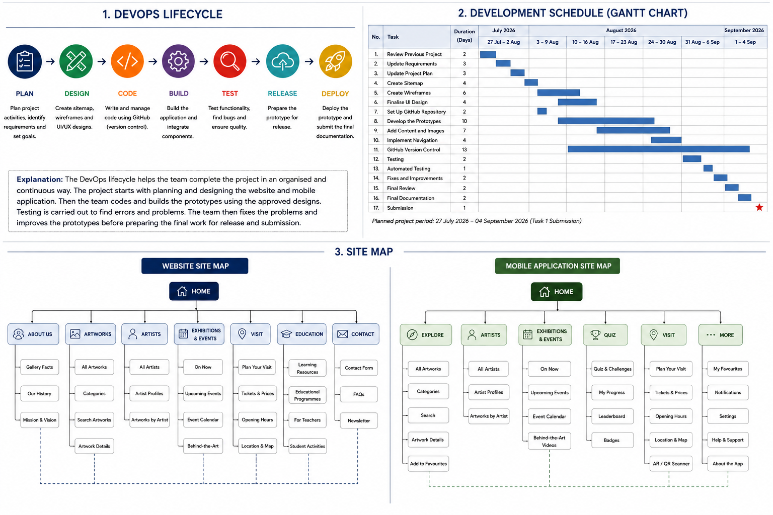
Figure 2: Project Schedule Table

DevOps Lifecycle

The DevOps lifecycle is used to organize the development process from the initial planning stage through to the final deployment of the project. It allows the team to work through the project in stages while continuously testing, improving and managing the project files. The project will follow a DevOps lifecycle to help the team plan, develop, test and improve the website and mobile application. The main stages used in this project are:
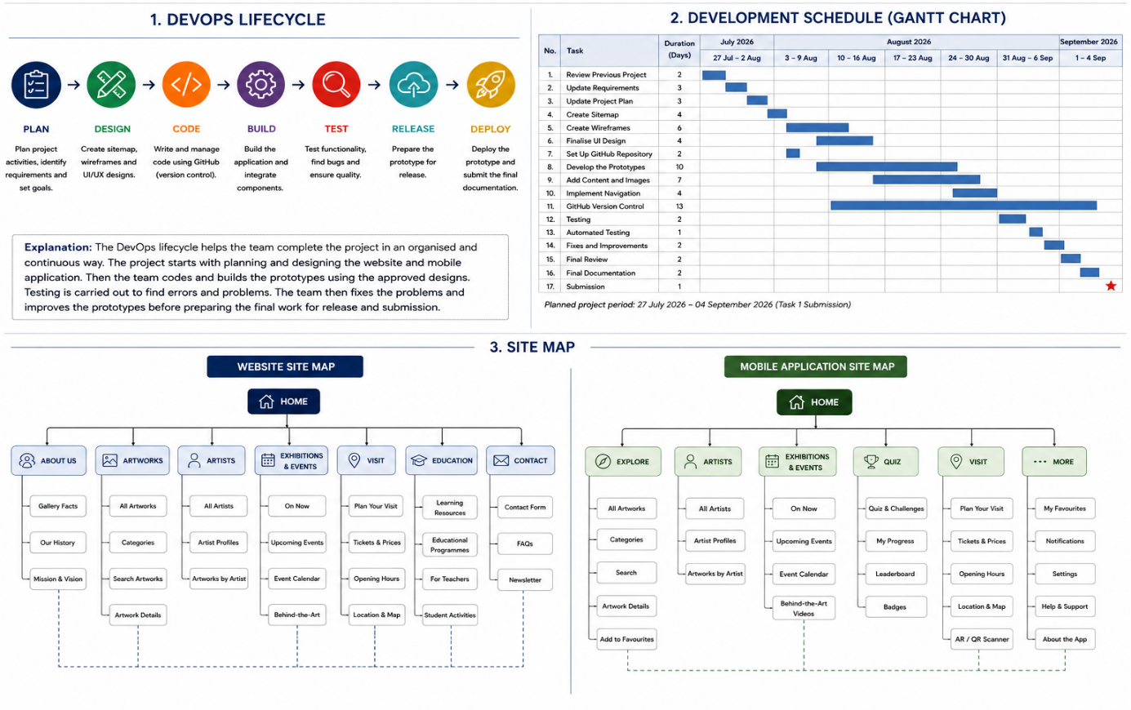

Figure 3: DevOps Lifecycle Diagram

The DevOps lifecycle will be used to guide the development of the Iziko Museum website and mobile application. The team will first plan the project and design the sitemap and wireframes. The development stage will then be used to build the website and mobile application. The project will be tested to identify and fix errors. After testing, improvements will be made before the final prototype and documentation are prepared for submission.

Site Maps

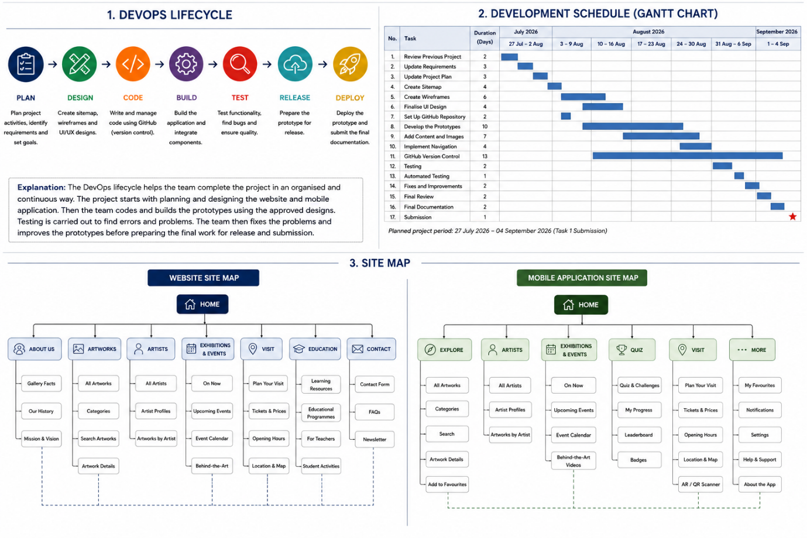
The sitemap shows the structure and navigation of the proposed Iziko South African National Gallery website and mobile application. It identifies the main sections of the system and the pages or screens that users can access from each section. Separate sitemaps are provided for the website and mobile application because the two platforms have different navigation requirements.
Figure 4: Website Site Map

Figure 5: Mobile Application Site Map

Team Members and Allocation

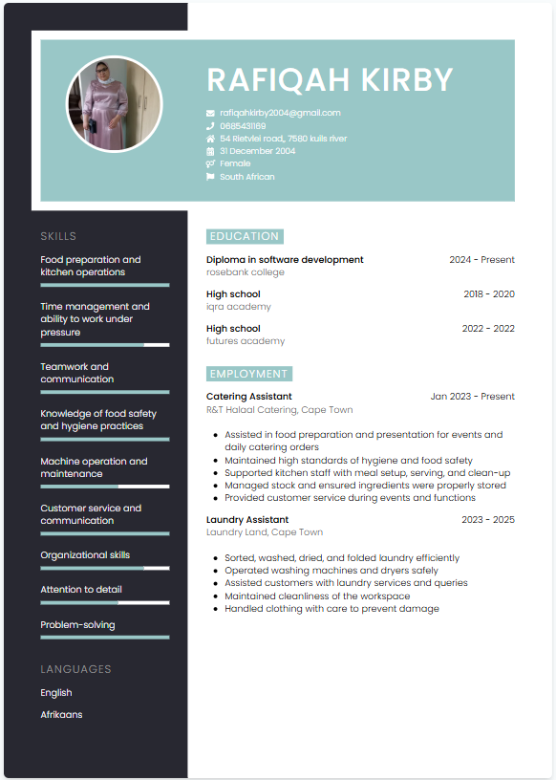
Team Leader
Role: Project Manager

Figure 6: Rafiqah CV

Responsibilities:
- Planning and coordinating all project activities
- Project tracking ensuring deadlines are met according to the Gantt chart
- Communicate with the client (Iziko Museums of South Africa)
- Oversee documentation and final submission
- Design user interface screens (Figma or similar tools)

Team Member
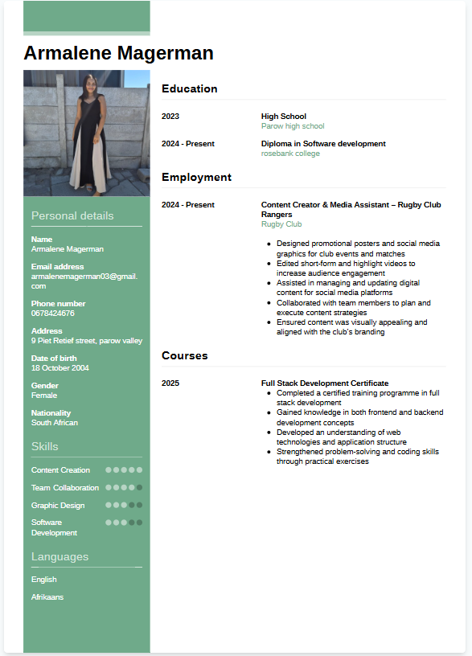
Role: Lead Developer / Programmer

Figure 7: Armalene CV

Responsibilities:
- Develop the mobile application using Kotlin/Android Studio
- Implement system features (gallery, videos, QR scanning, tracking)
- Perform testing and fix errors
- Assist with testing and deployment
- GitHub
- README
- Website development
- Functionality

Team Member
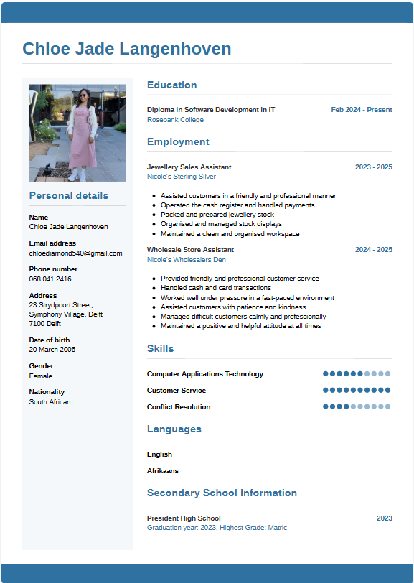
Role: System Designer / UI Designer

Figure 8: Chloe CV

Responsibilities:
- Ensure the system is user-friendly and visually appealing
- Assist with documentation related to page layouts
- Sitemap
- Wireframes
- UI design
- Visual content

Wireframes
The wireframes show the proposed layout and structure of the website and mobile application before the final development is completed. The designs are based on the existing Iziko South African National Gallery prototype developed from the previous project. The updated wireframes maintain a consistent visual identity while showing how the website and mobile application will provide users with access to artwork, artists, exhibitions, events and visitor information.

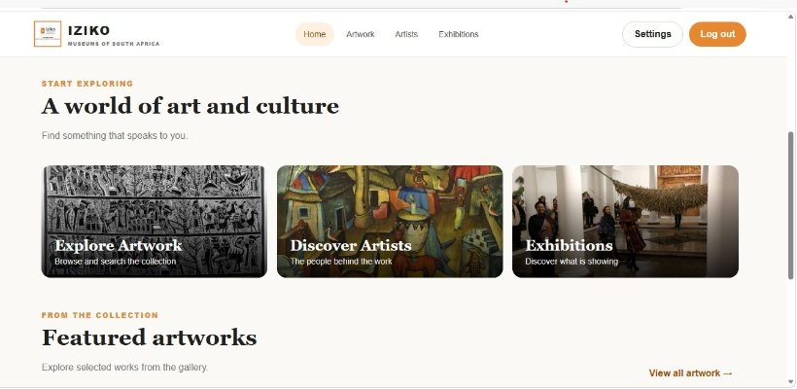
Website wireframe
These images show the different screens on our website.
Figure 17: Website screens

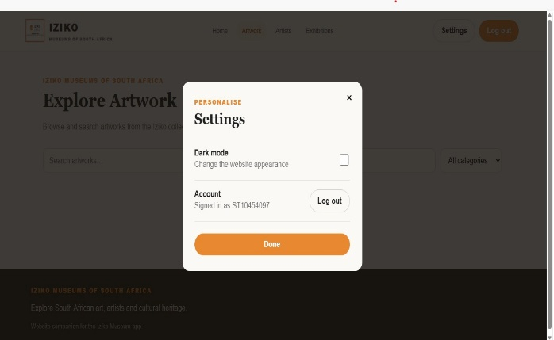
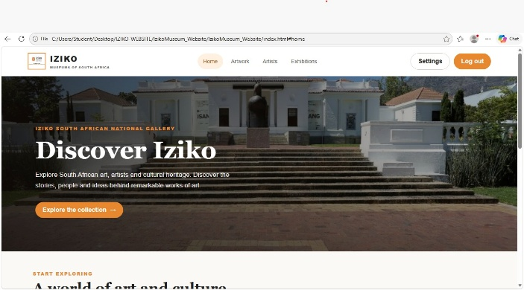
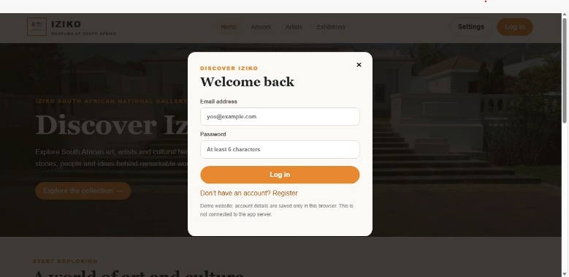
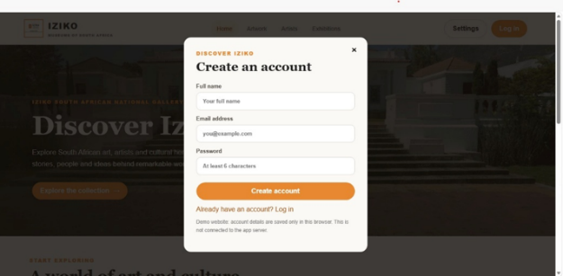
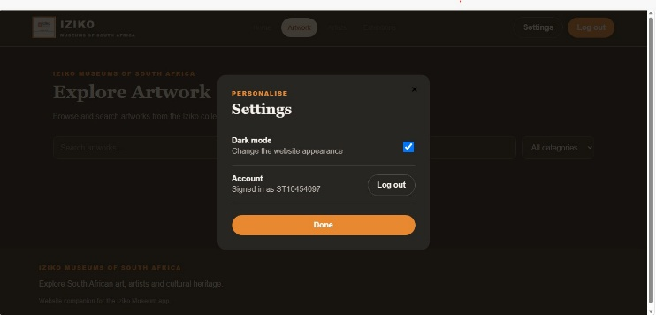
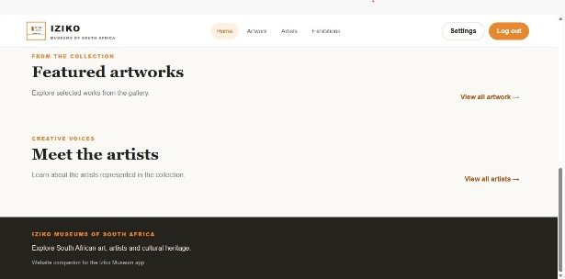

App wireframes

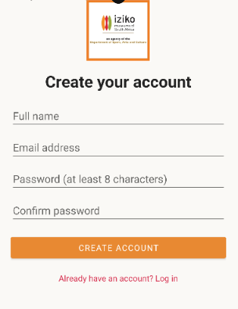
Register Screen
On the Register screen the user will fill in their full name (name and surname), their email address and their password of choice. The password requires a capital letter, a symbol and at least one number. The password can’t be anything less than 8 characters. Once the create account button is pressed it will take the user to the Login screen

Figure 9: Register screen

Login screen
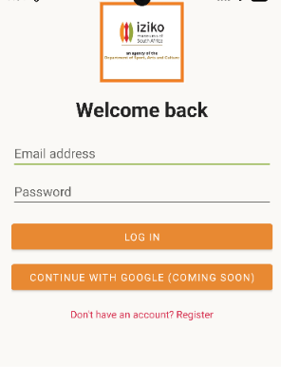
On the Login screen the user will fill in the details they just created and then proceed to the login button. The user can also click “Don’t have an account? Register” if they haven’t registered yet. The login button will take them to the Home/Welcome screen.

Figure 10: Login screen
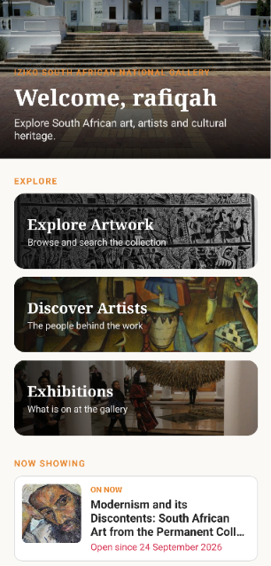
Home / Welcome screen
The user will be welcomed using their name, as they scroll down, they will see the Explore artwork, Discover Artist, Exhibitions and the now showing. The user can click on whichever page they want to visit.

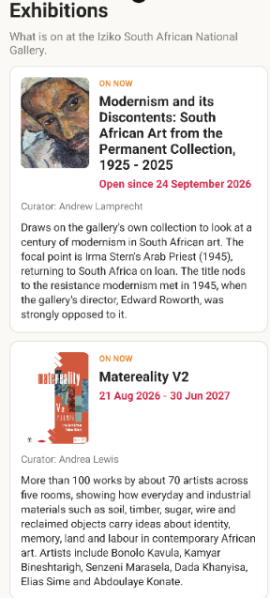
Exhibitions screen
On this page the user can explore the upcoming events taking place and is able to find the museum’s details to make a booking to visit the Art gallery.

Figure 11: Home /Welcome screen

Figure 12: Exhibitions Screen

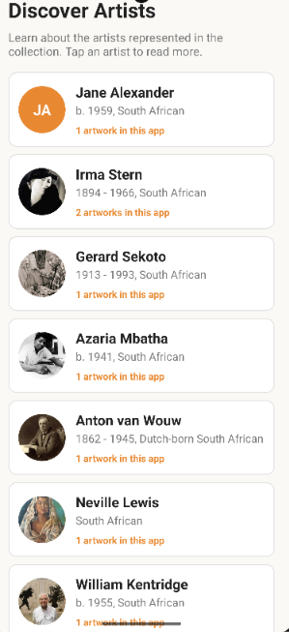
Discover Artist screen
On this Screen the user can see the artist and some information about them as well as the name of their artwork.

Figure 13: Discover Artist screen

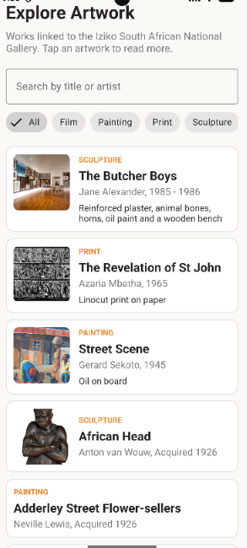

Explore Artwork screen
On this screen the user can see the different types of artwork and some information about them. The user can also search for artwork. Some of the artwork has images that the user can look at.

Figure 14: Explore Artwork screen

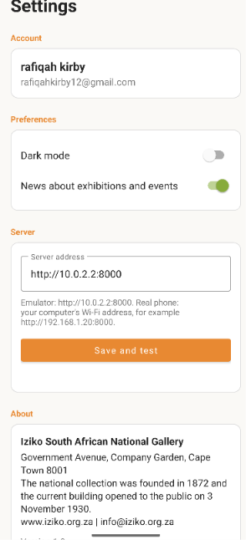

Settings Screen
On this page the user will be able to see their login details such as their name, surname and email address. They can also switch between dark and light. The user also has the option of receiving news about exhibitions and events or not. There is also the log out button if they plan on leaving the app. They can also find a brief about at the bottom on the page.

Figure 15: Settings Screen

Guide on how to set up app
This guide explains how to set up and run the Iziko Museum Android app.
Step 1: Download the project
- Open this GitHub repository( https://github.com/ST10438554-kirby/IzikoArtGalleryApp )
- Select Download ZIP.
- Once the download finishes, open your Downloads folder.
- Right-click the ZIP file and select Extract All.
- Choose a folder where you want to keep the project.
You should now have a folder containing the Iziko Museum project.
Step 2: Install Python
Python is needed to run the app's database server.
- Open the Python installer provided in this repository, or download Python from the official website: https://www.python.org/downloads/windows/
- Double-click the downloaded installer.
- If you see the option Add python.exe to PATH, tick the checkbox.
- Click Install Now.
- Wait for the installation to finish.
- Click Close.
Check that Python is installed
- Press the Windows key and the letter R together.
- Type cmd and press Enter.
- A black window called Command Prompt will open.
- Type the following command and press Enter:
python --version
Step 3: Start the database server
The database server supplies the museum information to the Android app.
- Open the folder where you extracted the project.
- Open the folder named server.
- Find the file named app.py. Windows may display it as app if file extensions are hidden.
- Click the address bar at the top of File Explorer.
- Type cmd and press Enter.
- In the black Command Prompt window, type:
python app.py
Press Enter.
Check that the server is running
You should see a message like:
Iziko API running on http://0.0.0.0:8000
The message may also show the location of the database file.
The server automatically creates the SQL database and loads the initial museum data when needed.
Keep the Command Prompt window open while using the app. Closing this window stops the server.
Step 4: Open the Android project
- Open Android Studio.
- Select Open.
- Find the extracted Iziko Museum project folder.
- Select the main project folder, not the server folder.
- Click Open.
- Wait for Android Studio to finish loading the project and syncing Gradle.
Step 5: Run the app
- In Android Studio, open Device Manager.
- Start an existing Android emulator or use a device.
- Select the preferred device.
- Click the green Run button.
- Wait for the Iziko Museum app to open.
- The address 10.0.2.2 allows the Android emulator to connect to the server running on your computer.
Do not enter http://0.0.0.0:8000 in the app.
If you are using a real Android phone
- Connect your phone and computer to the same Wi-Fi network.
- Find your computer's local IPv4 address.
- Open Settings → Server in the app.
- Enter your computer's address followed by8000, for example:
http://192.168.1.10:8000
Replace the example address with your computer's actual IPv4 address. Windows Firewall may need to allow the connection.
The app cannot reach the server
- Check that the server is running.
- Keep the Command Prompt window open.
- Test http://127.0.0.1:8000/api/health on your computer.
- For the Android emulator, use http://10.0.2.2:8000.
- For a real phone, use your computer's local Wi-Fi IPv4 address.
Quick reminder
Every time you want to use the app:
- Start the Python server.
- Keep the server running.
- Open Android Studio.
- Start the emulator.
- Run the Iziko Museum app.

References

Elmasri, R. and Navathe, S.B. (2016) Fundamentals of Database Systems. 7th edn. Boston: Pearson.
Hoffer, J.A., George, J.F. and Valacich, J.S. (2016) Modern Systems Analysis and Design. 9th edn. Harlow: Pearson.
International Organization for Standardization (2018) ISO 31000: Risk management – Guidelines. Geneva: ISO.
Iziko Museums of South Africa (2026) Official website. Available at: https://www.iziko.org.za (Accessed: 2 October 2026).
Kendall, K.E. and Kendall, J.E. (2019) Systems Analysis and Design. 10th edn. Harlow: Pearson.
Kerzner, H. (2017) Project Management: A Systems Approach to Planning, Scheduling, and Controlling. 12th edn. Hoboken: Wiley.
Labour Guide (2026) National minimum wage increase effective 1 March 2026. Available at: https://labourguide.co.za/employment-condition/national-minimum-wage-increase-effective-1-march-2026 (Accessed: 25 September 2026).
Microsoft (2026) Azure DevOps documentation. Available at: https://learn.microsoft.com/en-us/azure/devops/ (Accessed: 30 September 2026).
Oracle (2026) MySQL Documentation. Available at: https://dev.mysql.com/doc/ (Accessed: 30 September 2026).
Pressman, R.S. and Maxim, B.R. (2019) Software Engineering: A Practitioner’s Approach. 9th edn. New York: McGraw-Hill Education.
Python Software Foundation (2026) Python Downloads. Available at: https://www.python.org/downloads/windows/ (Accessed: 5 October 2026).
Satzinger, J.W., Jackson, R.B. and Burd, S.D. (2016) Systems Analysis and Design in a Changing World. 7th edn. Boston: Cengage Learning.
Schwalbe, K. (2019) Information Technology Project Management. 9th edn. Boston: Cengage Learning.
Sommerville, I. (2016) Software Engineering. 10th edn. Boston: Pearson.

